Plot/Visualization Deliverables

Jediniah Womack

CTEC 298-101

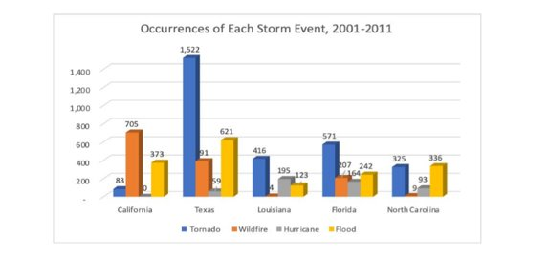

This plot was done in CTEC 128 and it was a bar graph. It had four types of storm events and five types of states for the graph.

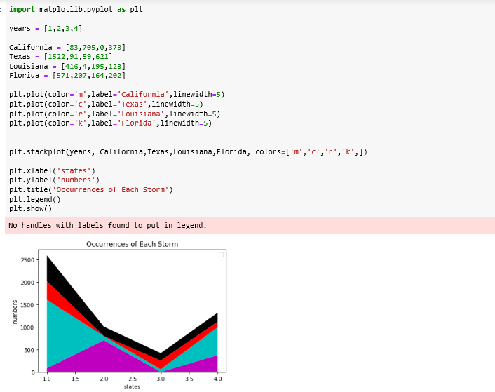

This plot was done in CTEC 298 and it is stack plot. It was made from the CTEC 128 graph ‘Occurrences of Each Storm’, which was a bar graph but made it into a stack plot. This stack plot had four states that I used and chose four colors to differentiate the states.

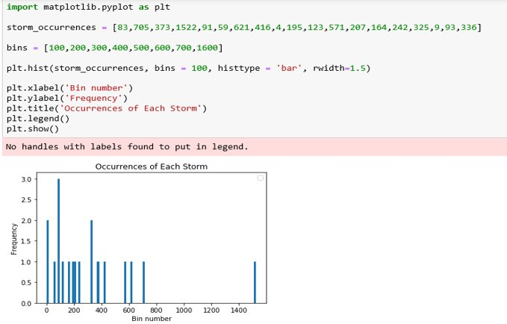

This plot was done in CTEC 298. I made this histogram in Jupyter Notebook from the ‘Occurrences of Each Storm’ graph in CTEC128. I put the data variables from the graph into bins to create this histogram. Each bar in the plot is 1.5 in width and the y-axis is the frequency and the x-axis is showing the bin number.

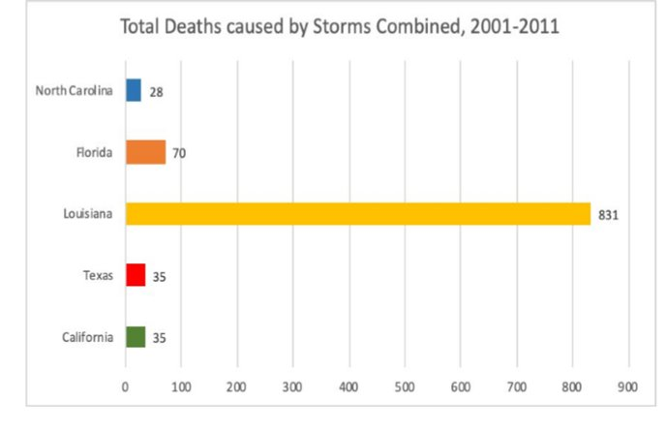

I did this plot in CTEC 128 and it was a bar graph. I did five states about the ‘Total Deaths caused by Storms Combined, 2001-2011'. This graph showed a clear view about the deaths in each state and had a outlier in Louisiana.

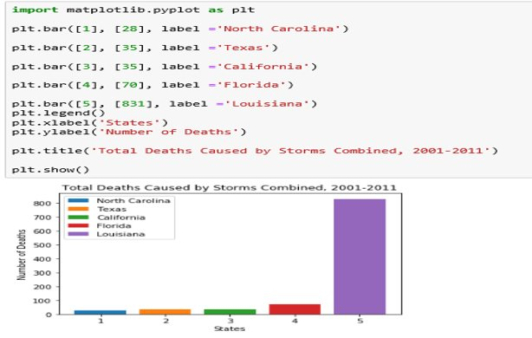

In this plot I made a bar graph from the ‘Total Deaths Caused by Storms Combined’ bar graph. I made five bars for each state. North Carolina is blue, Texas is orange, Florida is red, Louisiana is purple, and California is green. So the states is on the x-axis and the number of deaths is on the y-axis. This bar graph showed a clear view of which states and deaths happened from 2001-2011.

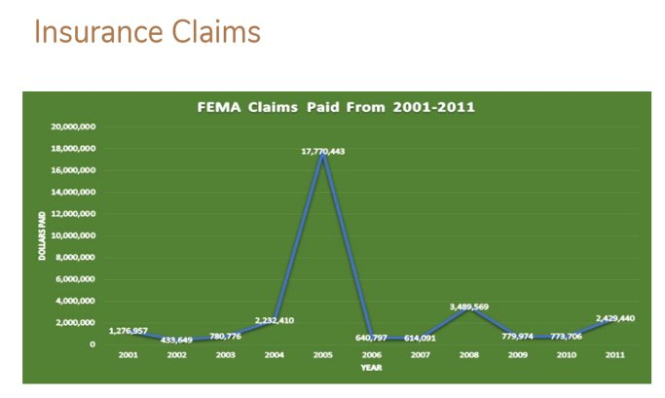

In this graph it was done in CTEC 128 and it is a line graph. It was over a ten-year span and shows the dollars paid from each year in those states.

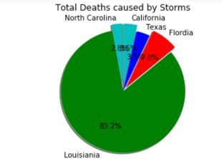

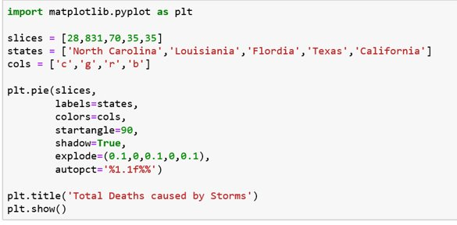

In this plot I made a pie plot from the ‘Total Deaths Caused by Storms’ bar graph. I made five slices into the five states I chose. I made Louisiana green as you can see and it has the biggest percentage of number. Showing Louisiana the having the highest number of deaths in their state.